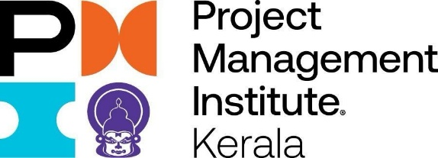

PMI KERALA AWARDS 2026
We are looking for exemplary projects from across India. And to meet resolute project teams who beat the odds to meet their project goals. Welcome to the PMI Kerala Awards - our goal is to recognize, honour and reward some of the biggest project management achievements in the region.
NOMINATIONS ARE FREE AND MULTIPLE SUBMISSIONS ARE ALLOWED. DO LET US KNOW YOUR INSPIRING PROJECT STORY. SOON!
Note: The nomination forms will be shared with the Juries for further evaluation. Kindly refrain from providing confidential data, if any.
Kindly provide authorization from your company to publish the company name to the media, and at the award function, if selected for awards.

Contact Information:
Name of the applicant:
Email:
Contact number

Project Nomination Form – Social Project of the Year

1. Organization Details
🟧 Organization Name
Full legal name and address of the organization

🟧 Industry
Industry sector the organization belongs to

🟧 Organization Overview
Brief overview of the organization, its mission, and key areas of work

2. Project Overview
🟧 Project Name

🟧 Project Executive Summary
High-level summary covering objectives, scale, beneficiaries, and duration

3. Define the Challenge
🟧 Challenge or Opportunity Addressed
What specific challenge or opportunity did your project address, and why was it important for your organization or community?

4. Scope, Methodology & Delivery
🟧 Project Scope and Social Impact
Describe scope, key activities, beneficiaries, and anticipated or realized social impact

🟧 Project Management Methodology Used
Waterfall / Agile / SAFe / Hybrid / Disciplined Agile / Kanban

🟧 Key Stakeholders
List internal and external stakeholders involved

🟧 Project Schedule
Overall duration with start and end dates

🟧 Project Cost
Approximate total cost or investment

5. Risk & Mitigation
🟧 Key Risks

🟧 Mitigation Strategies

6. Outcomes, Benefits & Project Success
🟧 Outcomes and Category Alignment
What measurable outcomes were achieved, and how do they demonstrate excellence for the Social Project category?

🟧 Benefits Realization / End-User Impact
Describe tangible and intangible benefits delivered to beneficiaries or the community

🟧 Project Success Beyond Scope, Schedule & Cost
How does this project reflect PMI’s definition of success—delivering value that is worth the effort and investment?

7. Strategic & PMI Values Alignment
🟧 Alignment with Organizational Goals
How did the project contribute to organizational mission, strategy, or priorities?

🟧 Demonstration of Project Management Excellence
Which project management practices were most critical to success and why?

🟧 PMI Values in Action
How did the team’s behaviors reflect PMI values — Make It Easy, Aim Higher,
Be Welcoming, Embrace Curiosity, and Together We Can?

8. Project Team
🟧 Key Team Members and Roles
Role | Name

9. Supporting Information
🟧 Additional Documents / Evidence
Mention any supporting documents, links, or evidence shared with this nomination

